%%%%%%%%%%%%%%%%%%%%%%%%%%%%%%%%%%%%%%%%%%%%%%%%%%%%%%%

**Example 4**

We carry out the simulation of aggregation-diffusion equation in a fan-shaped area with the initial data $ρ_{0} =e^{(−30(x^{2} + y^{2})) } + 0.01$. The internal energy density $H(ρ)$ and potential $W, V$ are described as follows:

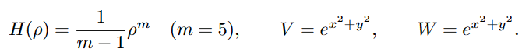

%%%%%%%%%%%%%%%%%%%%%%%%%%%%%%%%%%%%%%%%%%%%%%%%%%%%%%%

**Result**

1. **Free energy**

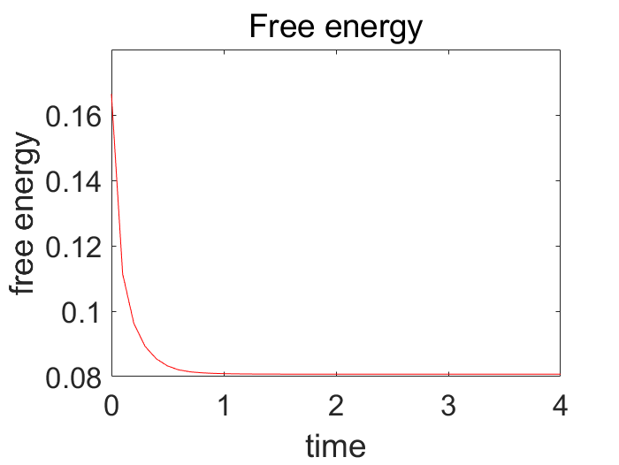

Figure 1 Mesh size(1/32), time step(tau=1/60000)

1. **The total mass**

The total mass at T=0: 7.459809e-02\*\*\*\*\*

The total mass at T=1.000000e-01: 7.459809e-02\*\*\*\*\*

The total mass at T=2.000000e-01: 7.459809e-02\*\*\*\*\*

The total mass at T=3.000000e-01: 7.459809e-02\*\*\*\*\*

The total mass at T=4.000000e-01: 7.459809e-02\*\*\*\*\*

The total mass at T=5.000000e-01: 7.459809e-02\*\*\*\*\*

The total mass at T=6.000000e-01: 7.459809e-02\*\*\*\*\*

The total mass at T=7.000000e-01: 7.459809e-02\*\*\*\*\*

The total mass at T=8.000000e-01: 7.459809e-02\*\*\*\*\*

The total mass at T=9.000000e-01: 7.459809e-02\*\*\*\*\*

The total mass at T=1: 7.459809e-02\*\*\*\*\*

The total mass at T=1.100000e+00: 7.459809e-02\*\*\*\*\*

The total mass at T=1.200000e+00: 7.459809e-02\*\*\*\*\*

The total mass at T=1.300000e+00: 7.459809e-02\*\*\*\*\*

The total mass at T=1.400000e+00: 7.459809e-02\*\*\*\*\*

The total mass at T=1.500000e+00: 7.459809e-02\*\*\*\*\*

The total mass at T=1.600000e+00: 7.459809e-02\*\*\*\*\*

The total mass at T=1.700000e+00: 7.459809e-02\*\*\*\*\*

The total mass at T=1.800000e+00: 7.459809e-02\*\*\*\*\*

The total mass at T=1.900000e+00: 7.459809e-02\*\*\*\*\*

The total mass at T=2: 7.459809e-02\*\*\*\*\*

The total mass at T=2.100000e+00: 7.459809e-02\*\*\*\*\*

The total mass at T=2.200000e+00: 7.459809e-02\*\*\*\*\*

The total mass at T=2.300000e+00: 7.459809e-02\*\*\*\*\*

The total mass at T=2.400000e+00: 7.459809e-02\*\*\*\*\*

The total mass at T=2.500000e+00: 7.459809e-02\*\*\*\*\*

The total mass at T=2.600000e+00: 7.459809e-02\*\*\*\*\*

The total mass at T=2.700000e+00: 7.459809e-02\*\*\*\*\*

The total mass at T=2.800000e+00: 7.459809e-02\*\*\*\*\*

The total mass at T=2.900000e+00: 7.459809e-02\*\*\*\*\*

The total mass at T=3: 7.459809e-02\*\*\*\*\*

The total mass at T=3.100000e+00: 7.459809e-02\*\*\*\*\*

The total mass at T=3.200000e+00: 7.459809e-02\*\*\*\*\*

The total mass at T=3.300000e+00: 7.459809e-02\*\*\*\*\*

The total mass at T=3.400000e+00: 7.459809e-02\*\*\*\*\*

The total mass at T=3.500000e+00: 7.459809e-02\*\*\*\*\*

The total mass at T=3.600000e+00: 7.459809e-02\*\*\*\*\*

The total mass at T=3.700000e+00: 7.459809e-02\*\*\*\*\*

The total mass at T=3.800000e+00: 7.459809e-02\*\*\*\*\*

The total mass at T=3.900000e+00: 7.459809e-02\*\*\*\*\*

The total mass at T=4: 7.459809e-02\*\*\*\*\*

1. **Numerical result**

|  |  |  |
| --- | --- | --- |
| rho_h_fill3_0  Figure 2 t = 0 | rho_h_fill3_1  Figure 3 t = 0.1 | rho_h_fill3_2  Figure 4 t = 0.2 |
| rho_h_fill3_10  Figure 5 t = 1 | rho_h_fill3_20  Figure 6 t = 2 | rho_h_fill3_40  Figure 7 t = 4 |